Pre- and Post-Winter Temperature Change Index and the Recruitment of Bering Sea
Pollock
Contributed by Ellen Yasumiishi, Auke Bay Laboratory, Alaska Fisheries Science Center, National
Marine Fisheries Service, NOAA

Ted Stevens Marine Research Institute, 17109 Point Lena Loop Road, Juneau, Alaska 99801-8626
Contact: ellen.yasumiishi@noaa.gov
Last updated: August 2017

Description of indicators: The temperature change (TC) index is a composite index for the pre-
and post-winter thermal conditions experienced by walleye pollock (Gadus chalcogrammus) from age-0 to age-1 in the eastern Bering Sea (Martinson et al., 2012). The TC index (year t) is calculated as the difference in the average monthly sea surface temperature in June (t) and August (t-1) (Figure 1) in an area of the southern region of the eastern Bering Sea (56.2°N to 58.1°N latitude by 166.9°W to 161.2°W longitude). Time series of average monthly sea surface temperatures were obtained from the NOAA Earth System Research Laboratory Physical Sciences Division website. Sea surface temperatures were based on NCEP/NCAR gridded reanalysis data (Kalnay et al., 1996, data obtained from http://www.esrl.noaa.gov/psd/cgi-bin/data/timeseries/timeseries1.pl ). Less negative values represent a cool late summer during the age-0 phase followed by a warm spring during the age-1 phase for pollock.
Status and trends: The 2018 TC index value is -4.01, higher than the 2017 TC index value of -6.61, indicating improved conditions for pollock survival from age-0 and age-1 from 2017 to 2018, respectively. The decrease in expected survival is due to the larger difference in sea temperature from late summer (warmer) to the following spring (cooler). However, both the late summer sea surface temperature (10.7 °C) in 2017 and spring sea temperatures (6.61 °C) in 2018 were warmer than the long-term average of 9.8 °C in late summer and 5.2 °C in spring since 1949. The TC index was positively correlated with subsequent recruitment of pollock to age-1 through age-4 from 1964 to 2018, but not significantly correlated for the shorter period (1997-2018).
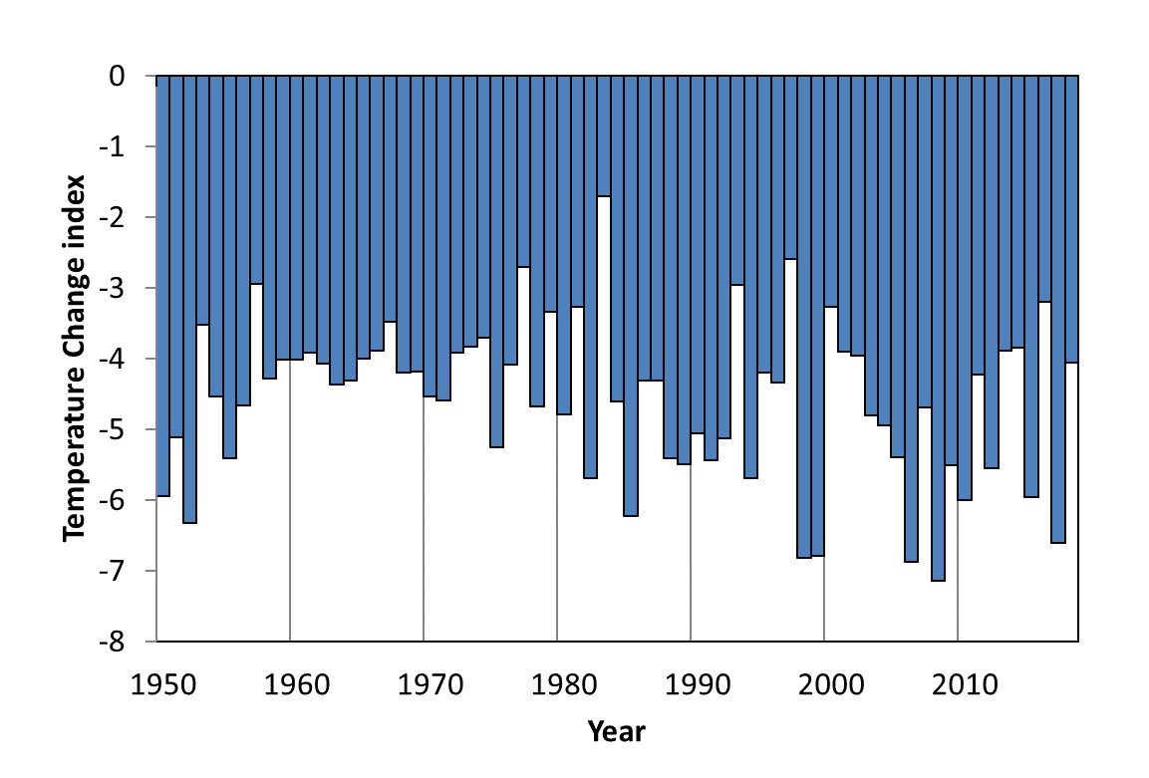

Figure 1: The Temperature Change index values from 1949 to 2018. Values represent the differences in sea temperatures on the south eastern Bering Sea shelf experienced by the 1948-2017 year classes of pollock. Less favorable conditions (more negative values) represent a warm summer during the age-0 life stage followed by a relatively cool spring during the age-1 life stage. More favorable conditions (less negative values) represent a cool summer during the age-0 life stage followed by a relatively warm spring during the age-1 life stage.

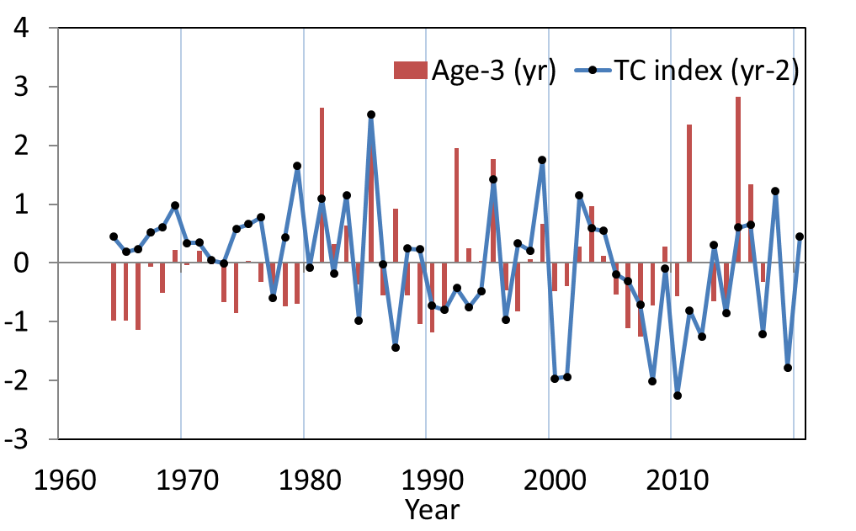

Figure 2: Normalized time series values of the temperature change index (t-2) from 1964-2020 indicating conditions experienced by the 1961-2017 year classes of pollock during the summer age-0 and spring age-1 life stages. Normalized values of the estimated abundance of age-3 walleye pollock in the eastern Bering Sea from 1964-2017 (t) for the 1961-2014 year classes. Age-3 walleye pollock estimates are from Table 28 in Ianelli et al. 2017. The TC index indicate above average conditions for the 2015 and 2017 year class and below average conditions for the 2016 year classes of pollock.

Table 1: Pearson's correlation coefficient relating the Temperature Change index to subsequent estimated year class strength of pollock. Bold values are statistically significant (p < 0.05).

Factors causing observed trends: According to the original Oscillating Control Hypothesis, warmer spring temperatures and earlier ice retreat led to a later oceanic and pelagic phytoplankton bloom and more food in the pelagic waters at an optimal time for use by pelagic species (Hunt et al., 2002). The revised OCH indicated that age-0 pollock were more energy-rich and have higher over wintering survival to age-1 in a year with a cooler late summer (Coyle et al., 2011; Heintz et al., 2013). Therefore, the colder later summers during the age-0 phase followed by warmer spring temperatures during the age-1 phase are assumed favorable for the survival of pollock from age-0 to age-1. The 2017 year class of pollock experienced a warm to average summer during the age-0 stage and a warm to average spring in 2018 during the age-1 stage indicating slightly above average conditions for over wintering survival from age-0 to age-1.

Implications: The 2018 TC index value of -4.06 was slightly above the long-term average of -4.61, therefore we expect average recruitment of pollock to age-3 in 2020 from the 2017 year class (Figure 2). The 2017 TC index value of -6.16 was below the long-term average of -4.61, therefore we expect lower than average recruitment of pollock to age-3 in 2019 from the 2016 year class (Figure 2). The 2016 TC index value of -3.19 was above the long-term average of -4.60, therefore we expect slightly above average recruitment of pollock to age-3 in 2018 from the 2015 year class. The 2015 TC index value of -5.96 was below the long-term average, therefore we expect slightly below average recruitment of pollock to age-3 in 2017 from the 2014 year class.

Literature Cited
Coyle, K. O., Eisner, L. B., Mueter, F. J., Pinchuk, A. I., Janout, M. A., Cieciel, K. D., ... & Andrews, A. G. (2011). Climate change in the southeastern Bering Sea: impacts on pollock stocks and implications for the oscillating control hypothesis. Fisheries Oceanography, 20(2), 139-156.

Heintz, R. A., Siddon, E. C., Farley, E. V., & Napp, J. M. (2013). Correlation between recruitment and fall condition of age-0 pollock (Theragra chalcogramma) from the eastern Bering Sea under varying climate conditions.Deep Sea Research Part II: Topical Studies in Oceanography, 94, 150-156.

Hunt Jr, G. L., Stabeno, P., Walters, G., Sinclair, E., Brodeur, R. D., Napp, J. M., & Bond, N. A. (2002). Climate change and control of the southeastern Bering Sea pelagic ecosystem. Deep Sea Research Part II: Topical Studies in Oceanography, 49(26), 5821-5853.

Hunt, G. L., Coyle, K. O., Eisner, L. B., Farley, E. V., Heintz, R. A., Mueter, F., ... & Stabeno, P. J. (2011). Climate impacts on eastern Bering Sea foodwebs: a synthesis of new data and an assessment of the Oscillating Control Hypothesis. ICES Journal of Marine Science: Journal du Conseil, fsr036.

Ianelli, J. N., Kotwicki, S., T. Honkalehto, S., Holsman, K. and Fissel, B. 2017. Assessment of walleye pollock stock in the Eastern Bering Sea. In: Stock Assessment and Fishery Evaluation Report for the Groundfish Resources of the Bering Sea/Aleutian Islands Regions. Anchorage: North Pacific Fisheries Management Council, pp. 55–183.
Kalnay, E., Kanamitsu, M., Kistler, R., Collins, W., Deaven, D., Gandin, L., Iredell, M., Saha, S., White, G., Woollen, J. and Zhu, Y., 1996. The NCEP/NCAR 40-year reanalysis project. Bulletin of the American meteorological Society, 77(3), pp. 437–471.
Martinson, E. C., Stokes, H. H., & Scarnecchia, D. L. 2012. Use of juvenile salmon growth and temperature change indices to predict groundfish post age‐0 yr class strengths in the Gulf of Alaska and eastern Bering Sea. Fisheries Oceanography, 21(4), 307-319.

